Project 3 – Loading Data into a Database

CREATE TABLE wikipages (

pg_id SERIAL PRIMARY KEY,

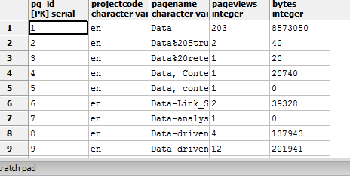projectcode VARCHAR,

pagename VARCHAR,

pageviews INT,

bytes INT);

COPY wikipages(

projectcode,

pagename,

pageviews,

bytes)

FROM 'C:\20141001140000.txt'

DELIMITER ' ';

## Select Top 5

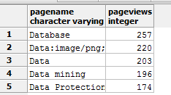SELECT pagename, pageviews

FROM wikipages

ORDER BY pageviews DESC

LIMIT 5;